**Physiology 115 Name ______________________________**Spring 2015

**QUIZ #2**

Weighting the quizzes: I have the idea of weighting the 3 multiple choice questions at 50% of the quiz, and the (short?) answer question at 50%. For question 4, I figure that4(a) is two-thirds of the question and 4(b) is one-third, which are 1/3rd and 1/6th, respectively, of the total quiz score. Thus, if I make the multiple choice questions 2 pts each, then 4(a) is 4 points and 4(b) is 2 points

For the multiple choice questions, there is *one* and *only one* best answer. Use the back of the sheet if you need to complete answers.

1. Triglycerides are composed of three fatty acids esterified (covalently bound as an ester) to:
   1. phospholipids
   2. LDL
   3. cholesterol
   4. **glycerol**
   5. glucose
2. Which of these receptor types has the ability to phosphorylate itself (autophosphorylation)?
   1. G-protein coupled receptor
   2. gap junction receptor
   3. **receptor tyrosine kinase**
   4. steroid hormone receptor
   5. claudin receptor
3. Which of these is an unsaturated fatty acid?
   1. C18:0
   2. **C16:1**
   3. C16:0
   4. both (a) and (c)
   5. none of the above
4. (a) Draw or briefly describe the lipoprotein as a layered spherical structure, showing the relative layering from center to surface of the following components: (i) apolipoprotein, (ii) phospholipid, (iii) triglyceride, (iv) cholesterol? (names of apolipoproteins are not important: just show the general positions of these components in a lipoprotein: keep in mind lipophilic & hydrophilic chemistry!)  
   (b) How is the density of a lipoprotein changed relative to the amount of lipid within it?

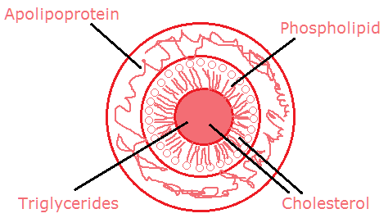

(a) The illustration need not be so detailed.  
a  
3 concentric layers with TG and cholesterol in the center, phospholipid in the next outer shell (cholesterol okay too), and apolipoprotein on the outermost shell

(b) Adding lipid to a molecule reduces its density relative to water or aqueous solutions, which is what bodily fluids really are. So the more fat/lipid there is a molecular assembly like a lipoprotein, the lower the density it acquires. This is why chylomicrons and VLDLs are quite low in density despite being larger in size: they have a great deal of fat content (size has no relationship to density!). What removes the fat gradually until it acquires LDL size? ***Lipoprotein lipase*** enzyme on the surface of some cells. When the particle becomes an LDL, it is taken out of the bloodstream then by ***LDL receptors***.